**Kaiju Fights**

**Game Design Document(GDD)**

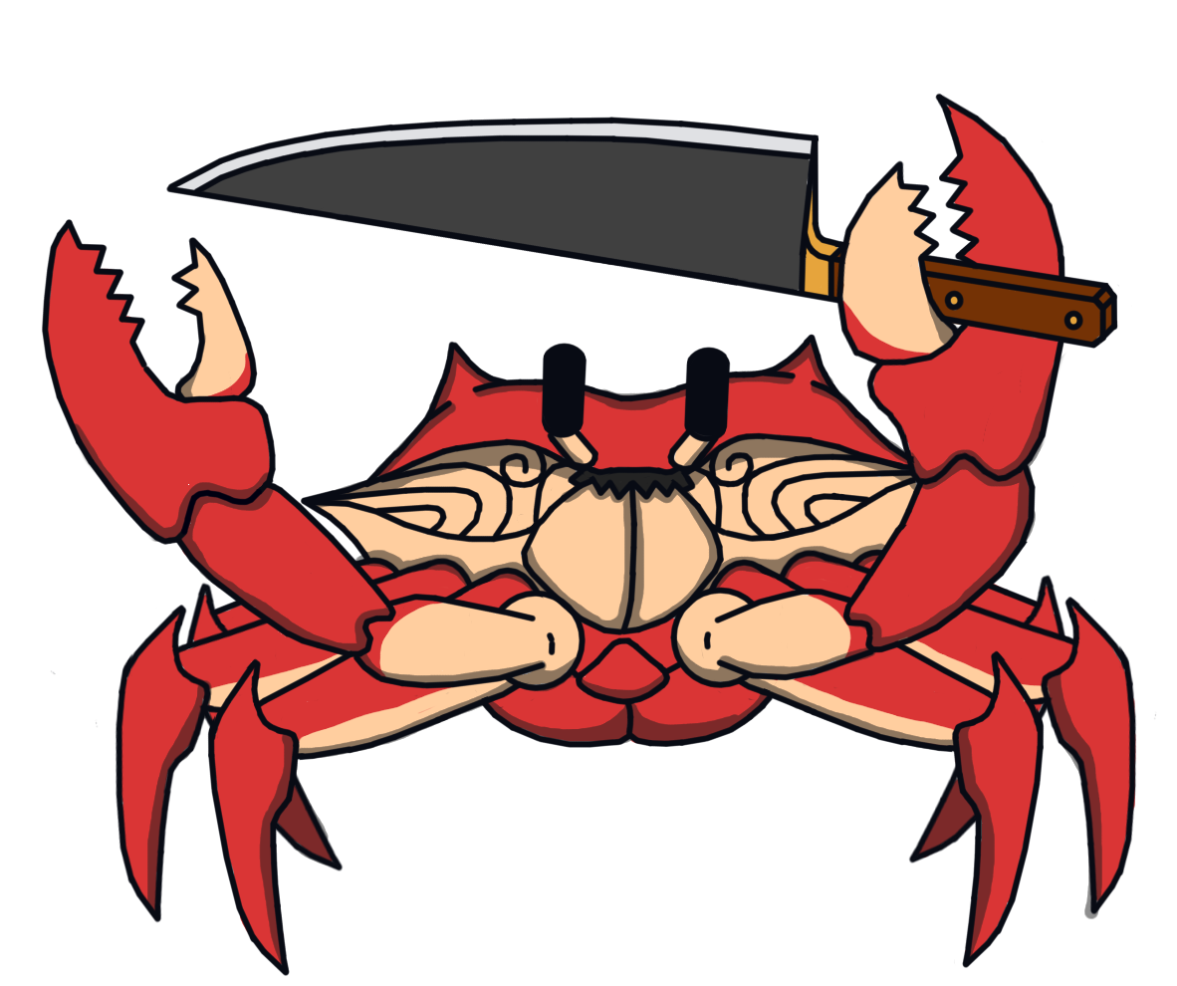

|  |  |  |
| --- | --- | --- |
| Table of Contents  [1 Game Overview](https://n-xovwktmtjsnaxyc2mwes2xu7pohqedmdm6zjw5q-2lu-script.googleusercontent.com/userCodeAppPanel)  [2 High Concept](https://n-xovwktmtjsnaxyc2mwes2xu7pohqedmdm6zjw5q-2lu-script.googleusercontent.com/userCodeAppPanel)  [3 Unique Selling Points](https://n-xovwktmtjsnaxyc2mwes2xu7pohqedmdm6zjw5q-2lu-script.googleusercontent.com/userCodeAppPanel)  [4 Platform Minimum Requirements](https://n-xovwktmtjsnaxyc2mwes2xu7pohqedmdm6zjw5q-2lu-script.googleusercontent.com/userCodeAppPanel)  [5 Competitors / Similar Titles](https://n-xovwktmtjsnaxyc2mwes2xu7pohqedmdm6zjw5q-2lu-script.googleusercontent.com/userCodeAppPanel)  [6 Synopsis](https://n-xovwktmtjsnaxyc2mwes2xu7pohqedmdm6zjw5q-2lu-script.googleusercontent.com/userCodeAppPanel)  [7 Game Objectives](https://n-xovwktmtjsnaxyc2mwes2xu7pohqedmdm6zjw5q-2lu-script.googleusercontent.com/userCodeAppPanel)  [8 Game Rules](https://n-xovwktmtjsnaxyc2mwes2xu7pohqedmdm6zjw5q-2lu-script.googleusercontent.com/userCodeAppPanel)  [9 Game Structure](https://n-xovwktmtjsnaxyc2mwes2xu7pohqedmdm6zjw5q-2lu-script.googleusercontent.com/userCodeAppPanel)  [10 Game Play](https://n-xovwktmtjsnaxyc2mwes2xu7pohqedmdm6zjw5q-2lu-script.googleusercontent.com/userCodeAppPanel)  [10.1 Game Controls](https://n-xovwktmtjsnaxyc2mwes2xu7pohqedmdm6zjw5q-2lu-script.googleusercontent.com/userCodeAppPanel)  [10.2 Game Camera](https://n-xovwktmtjsnaxyc2mwes2xu7pohqedmdm6zjw5q-2lu-script.googleusercontent.com/userCodeAppPanel)  [10.2.1 HUD](https://n-xovwktmtjsnaxyc2mwes2xu7pohqedmdm6zjw5q-2lu-script.googleusercontent.com/userCodeAppPanel)  [10.2.2 Maps](https://n-xovwktmtjsnaxyc2mwes2xu7pohqedmdm6zjw5q-2lu-script.googleusercontent.com/userCodeAppPanel)  [11 Players](https://n-xovwktmtjsnaxyc2mwes2xu7pohqedmdm6zjw5q-2lu-script.googleusercontent.com/userCodeAppPanel)  [11.1 Characters](https://n-xovwktmtjsnaxyc2mwes2xu7pohqedmdm6zjw5q-2lu-script.googleusercontent.com/userCodeAppPanel)  [11.2 Metrics](https://n-xovwktmtjsnaxyc2mwes2xu7pohqedmdm6zjw5q-2lu-script.googleusercontent.com/userCodeAppPanel)  [11.3 States](https://n-xovwktmtjsnaxyc2mwes2xu7pohqedmdm6zjw5q-2lu-script.googleusercontent.com/userCodeAppPanel)  [11.4 Weapons](https://n-xovwktmtjsnaxyc2mwes2xu7pohqedmdm6zjw5q-2lu-script.googleusercontent.com/userCodeAppPanel)  [12 Player Line-up](https://n-xovwktmtjsnaxyc2mwes2xu7pohqedmdm6zjw5q-2lu-script.googleusercontent.com/userCodeAppPanel)  [13 Art](https://n-xovwktmtjsnaxyc2mwes2xu7pohqedmdm6zjw5q-2lu-script.googleusercontent.com/userCodeAppPanel)  [13.1 Setting](https://n-xovwktmtjsnaxyc2mwes2xu7pohqedmdm6zjw5q-2lu-script.googleusercontent.com/userCodeAppPanel)  [13.2 Level Design](https://n-xovwktmtjsnaxyc2mwes2xu7pohqedmdm6zjw5q-2lu-script.googleusercontent.com/userCodeAppPanel)  [13.3 Audio](https://n-xovwktmtjsnaxyc2mwes2xu7pohqedmdm6zjw5q-2lu-script.googleusercontent.com/userCodeAppPanel)  [14 Procedurally Generated Content](https://n-xovwktmtjsnaxyc2mwes2xu7pohqedmdm6zjw5q-2lu-script.googleusercontent.com/userCodeAppPanel)  [14.1 Environment](https://n-xovwktmtjsnaxyc2mwes2xu7pohqedmdm6zjw5q-2lu-script.googleusercontent.com/userCodeAppPanel)  [14.2 Levels](https://n-xovwktmtjsnaxyc2mwes2xu7pohqedmdm6zjw5q-2lu-script.googleusercontent.com/userCodeAppPanel)  [14.3 Artificial Intelligence NPC](https://n-xovwktmtjsnaxyc2mwes2xu7pohqedmdm6zjw5q-2lu-script.googleusercontent.com/userCodeAppPanel)  [14.6 Minimum Viable Product (MPV)](https://n-xovwktmtjsnaxyc2mwes2xu7pohqedmdm6zjw5q-2lu-script.googleusercontent.com/userCodeAppPanel)  [15 Wish List](https://n-xovwktmtjsnaxyc2mwes2xu7pohqedmdm6zjw5q-2lu-script.googleusercontent.com/userCodeAppPanel)  [16](https://n-xovwktmtjsnaxyc2mwes2xu7pohqedmdm6zjw5q-2lu-script.googleusercontent.com/userCodeAppPanel) Works Cited   |  | | --- | |  | | Game Development Team Member PRODUCER  Joseph Hartman  PRODUCTION MANAGER  Jerel Esmende  PRODUCTION COORDINATOR  Amanda Buscagan  GAME DESIGNERS  Joseph Hartman  Bon Talavera  SYSTEMS/IT COORDINATOR  Amanda Buscagan  PROGRAMMERS  Joseph Hartman  Jerel Esmende  Bon Talavera  Amanda Buscagan  TECHNICAL ARTISTS  Jerel Esmende  AUDIO ENGINEERS  Bon Talavera  UX TESTERS  Joseph Hartman |

# **1 Game Overview**

Title: Kaiju Fights

Platform: PC Standalone + iOS & Android, VR, XBox, Switch,

Genre: Turn-Based RPG

Rating: (10+) ESRB

Target: Casual gamer (aging from 12 - 30)

Serious games

Release date: April, 2016

Publisher: Doomer’s Studios

Description: A turn based rogue-like rpg that puts giant kaiju monsters in a battle of island supremacy. The player can select which monsters they would like to use to combat the other monsters. The game uses 2D elements in a 3D setting. The monster will keep fighting for the longest time they can.

# **2 High Concept**

Kaiju Fights sets the Player to control their choice of giant Kaiju monsters in order to battle with other monsters on the waters of a remote collection of islands. Become the king of monsters as you fight your way through the gauntlet of numerous islands by outwitting your opponents in an exciting turn-based combat! Defend, attack, the choice is yours! There will only be one king and it is up to you to conquer all.

# **3 Unique Selling Points**

* Unique and great art
* Wonderful turn-based combat
* Generous selection of hand-crafted monsters
* Aesthetically pleasing swarms of birds denoting monster encounters

# **4 Platform Minimum Requirements**

MAC

OS: Mac OS X 10.8+

Graphics card: AMD Radeon 7950

PC

OS: Windows 10 x64 or Mac

Processor: AMD A6

Memory: 4 GB RAM

Graphics: AMD Radeon R6

Network: Broadband Internet connection

Sound Card: DirectX compatible

# **5 Competitors / Similar Titles**

Paper Mario by Intelligent Systems

# **6 Synopsis**

You are a monster and the goal of the game is world domination. You obtain your goal by beating up all the monsters as you hop from island to island.

# **7 Game Objectives**

Keep fighting all the monsters until you die.

# **8 Game Rules**

Kaiju Fight’s game levels are constrained to randomly generated islands with a random amount of encounters of about 1 to 5. The player may click on available encounters to initiate a fight sequence with other monsters in a generated scene to which monsters will be displayed on two opposing sides with clickable options to attack or defend. The goal of the game is to clear out island after island in varying number of encounters until their monster perishes or they become bored of the game.

# **9 Game Structure**

**CHARACTER SELECTION ->**

**GAMEPLAY (Endless)**

**Enter overview map ->**

**Select encounter ->**

**Fight monsters ->**

**Repeat until Player controlled monster perishes ->**

**Credits**

# **10 Game Play**

The main game play consists of turn based combat. With several attacks the player can use depending on the situation.

## **10.1 Game Controls**

The game will be mostly utilizing UI buttons for the turn based combat. Therefore a mouse on PC is most suitable to select options.

## **10.2 Game Camera**

Since the core of the game is a view of 2D onto 3D spaces the only camera will be on flat 2D pages such as the character selection screen, main menu, credits, battle scenes.

### 

As for 3D spaces they would be delegated to or a top down view at 40 degrees downwards onto the map overview.

### **10.2.1 HUD**

### **HealthBars:** Indicates hit points of both player and opponent monster

**OptionsButtons:** Includes options to attack, defend, health, or use a special attack to affect the enemy monster

### 

### 

### **10.2.2 Maps**

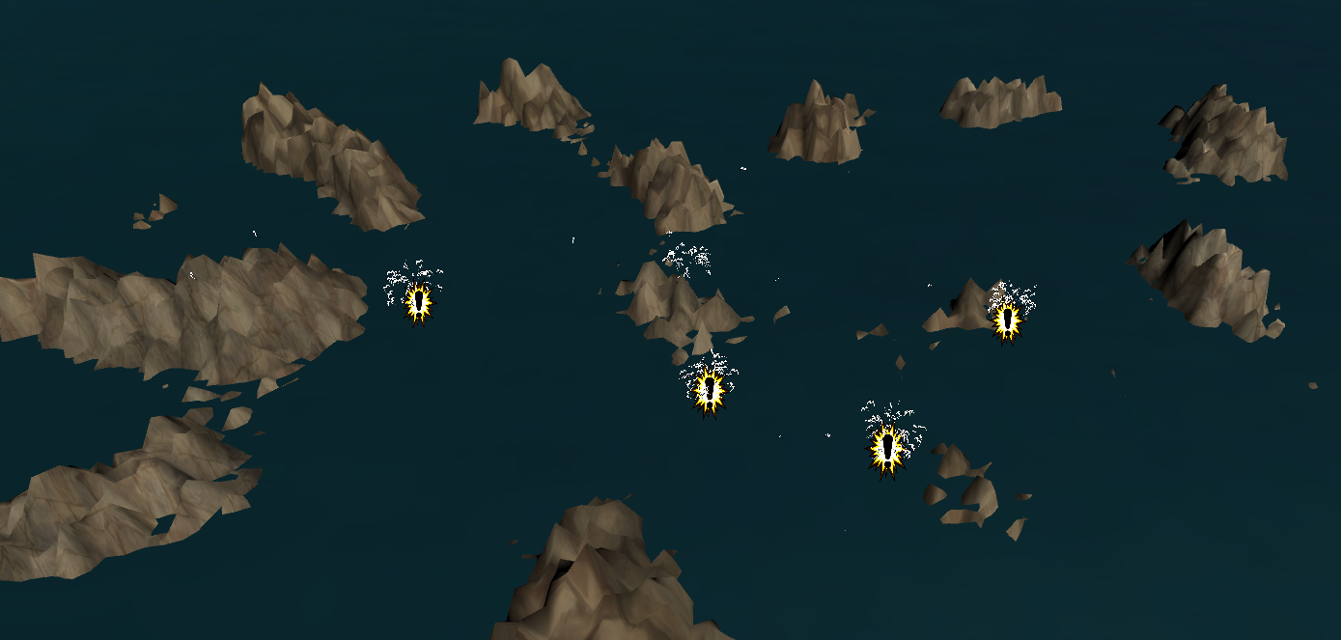

# **11 Players**

## **11.1 Characters**

Crab - Lobster -

 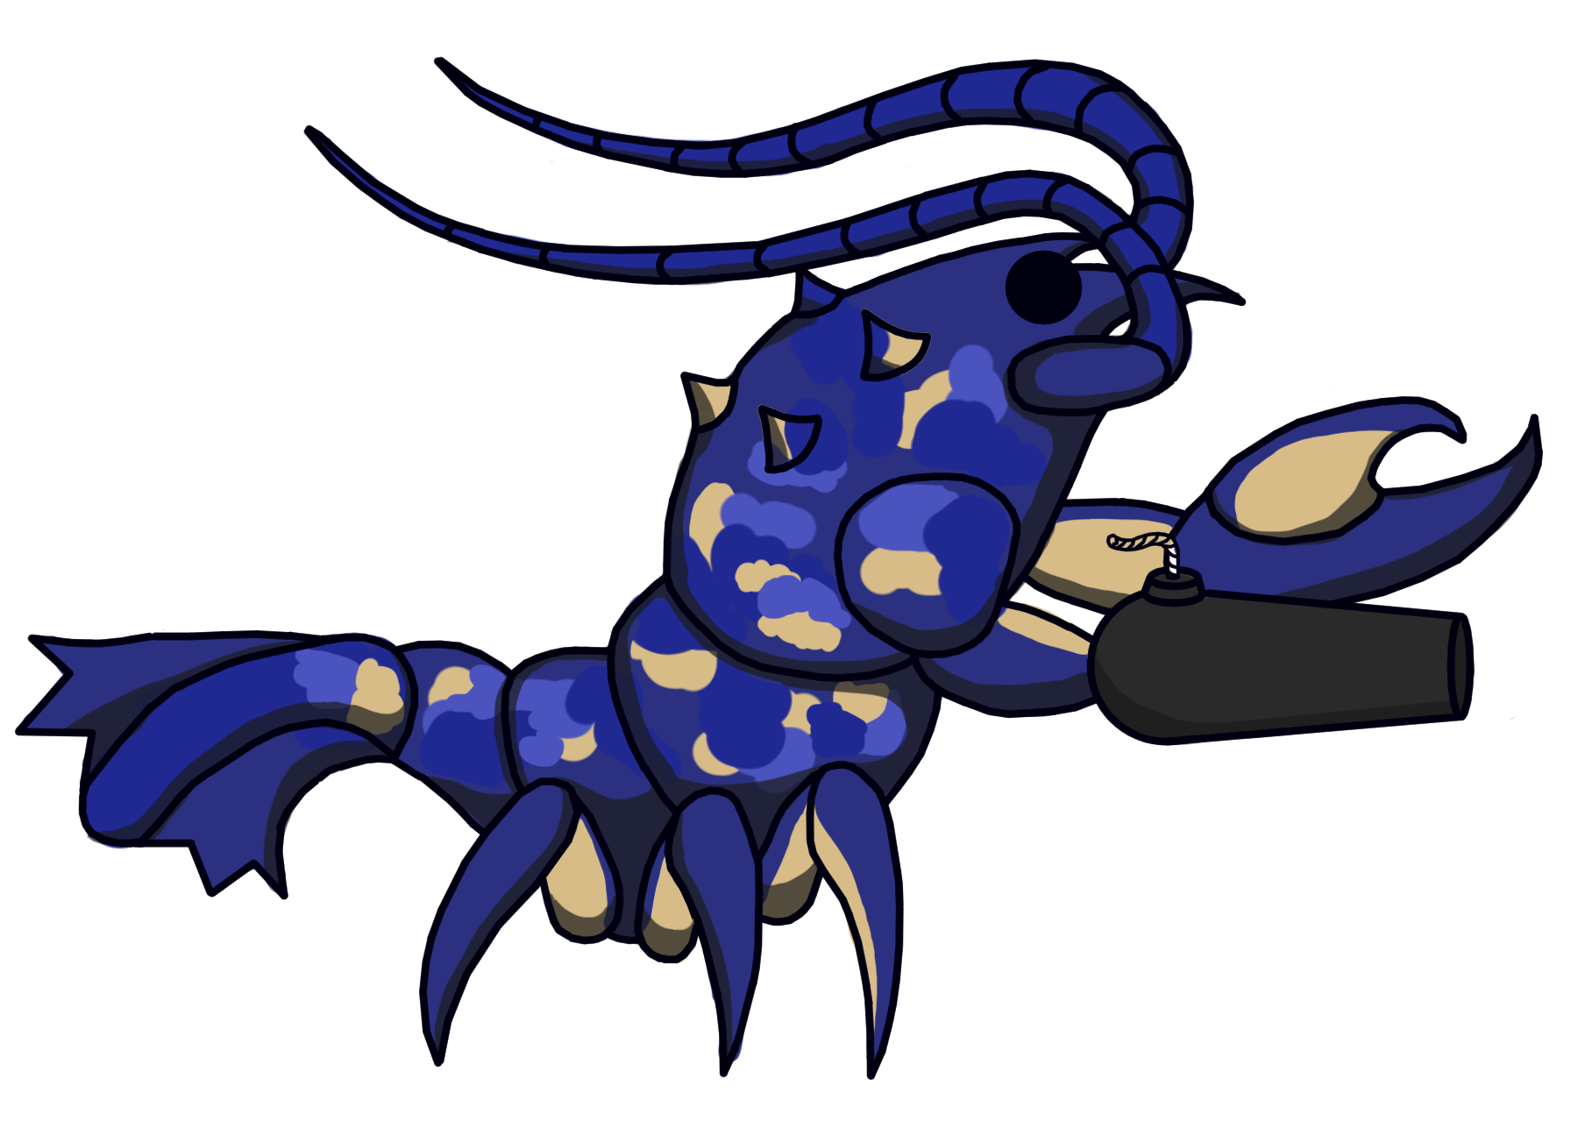

Angler - Snail -

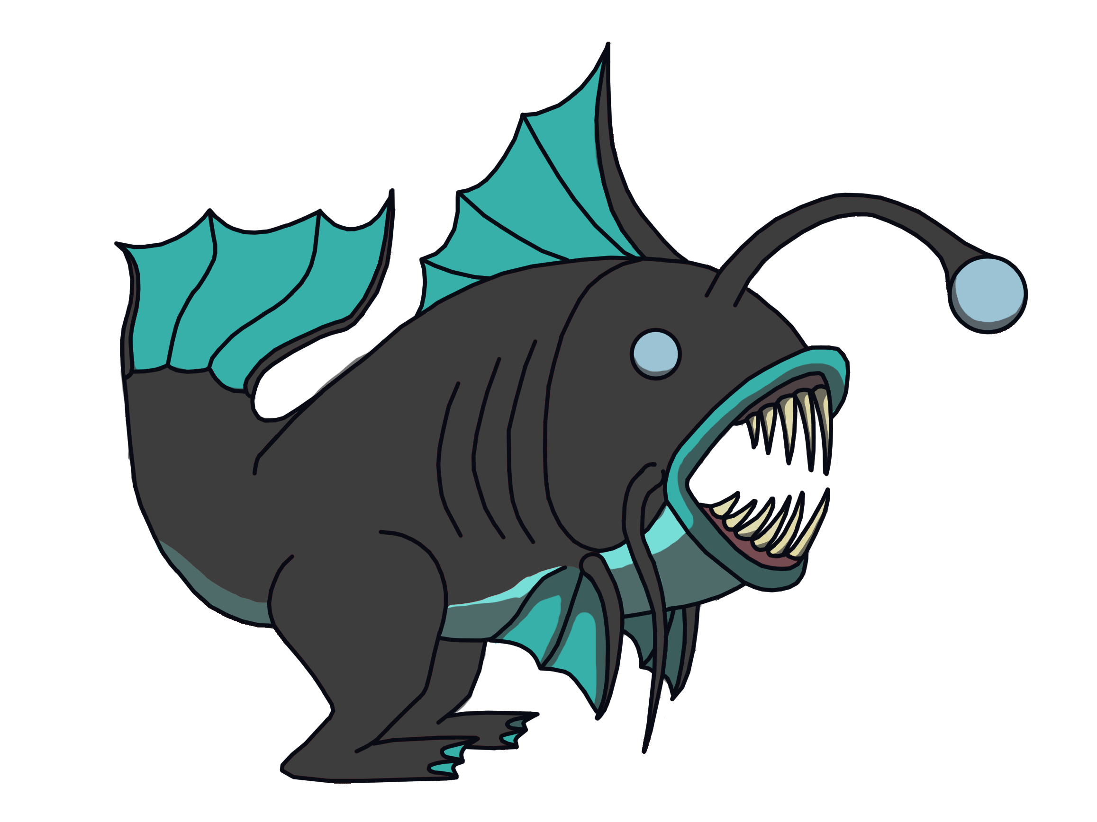 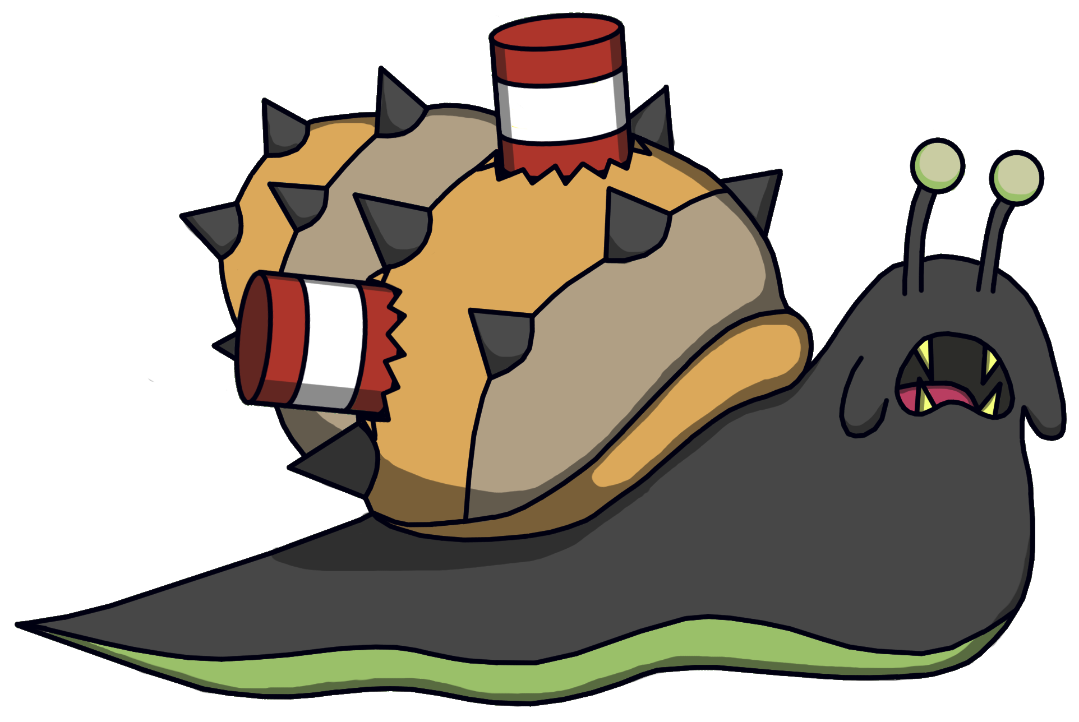

Turtle -

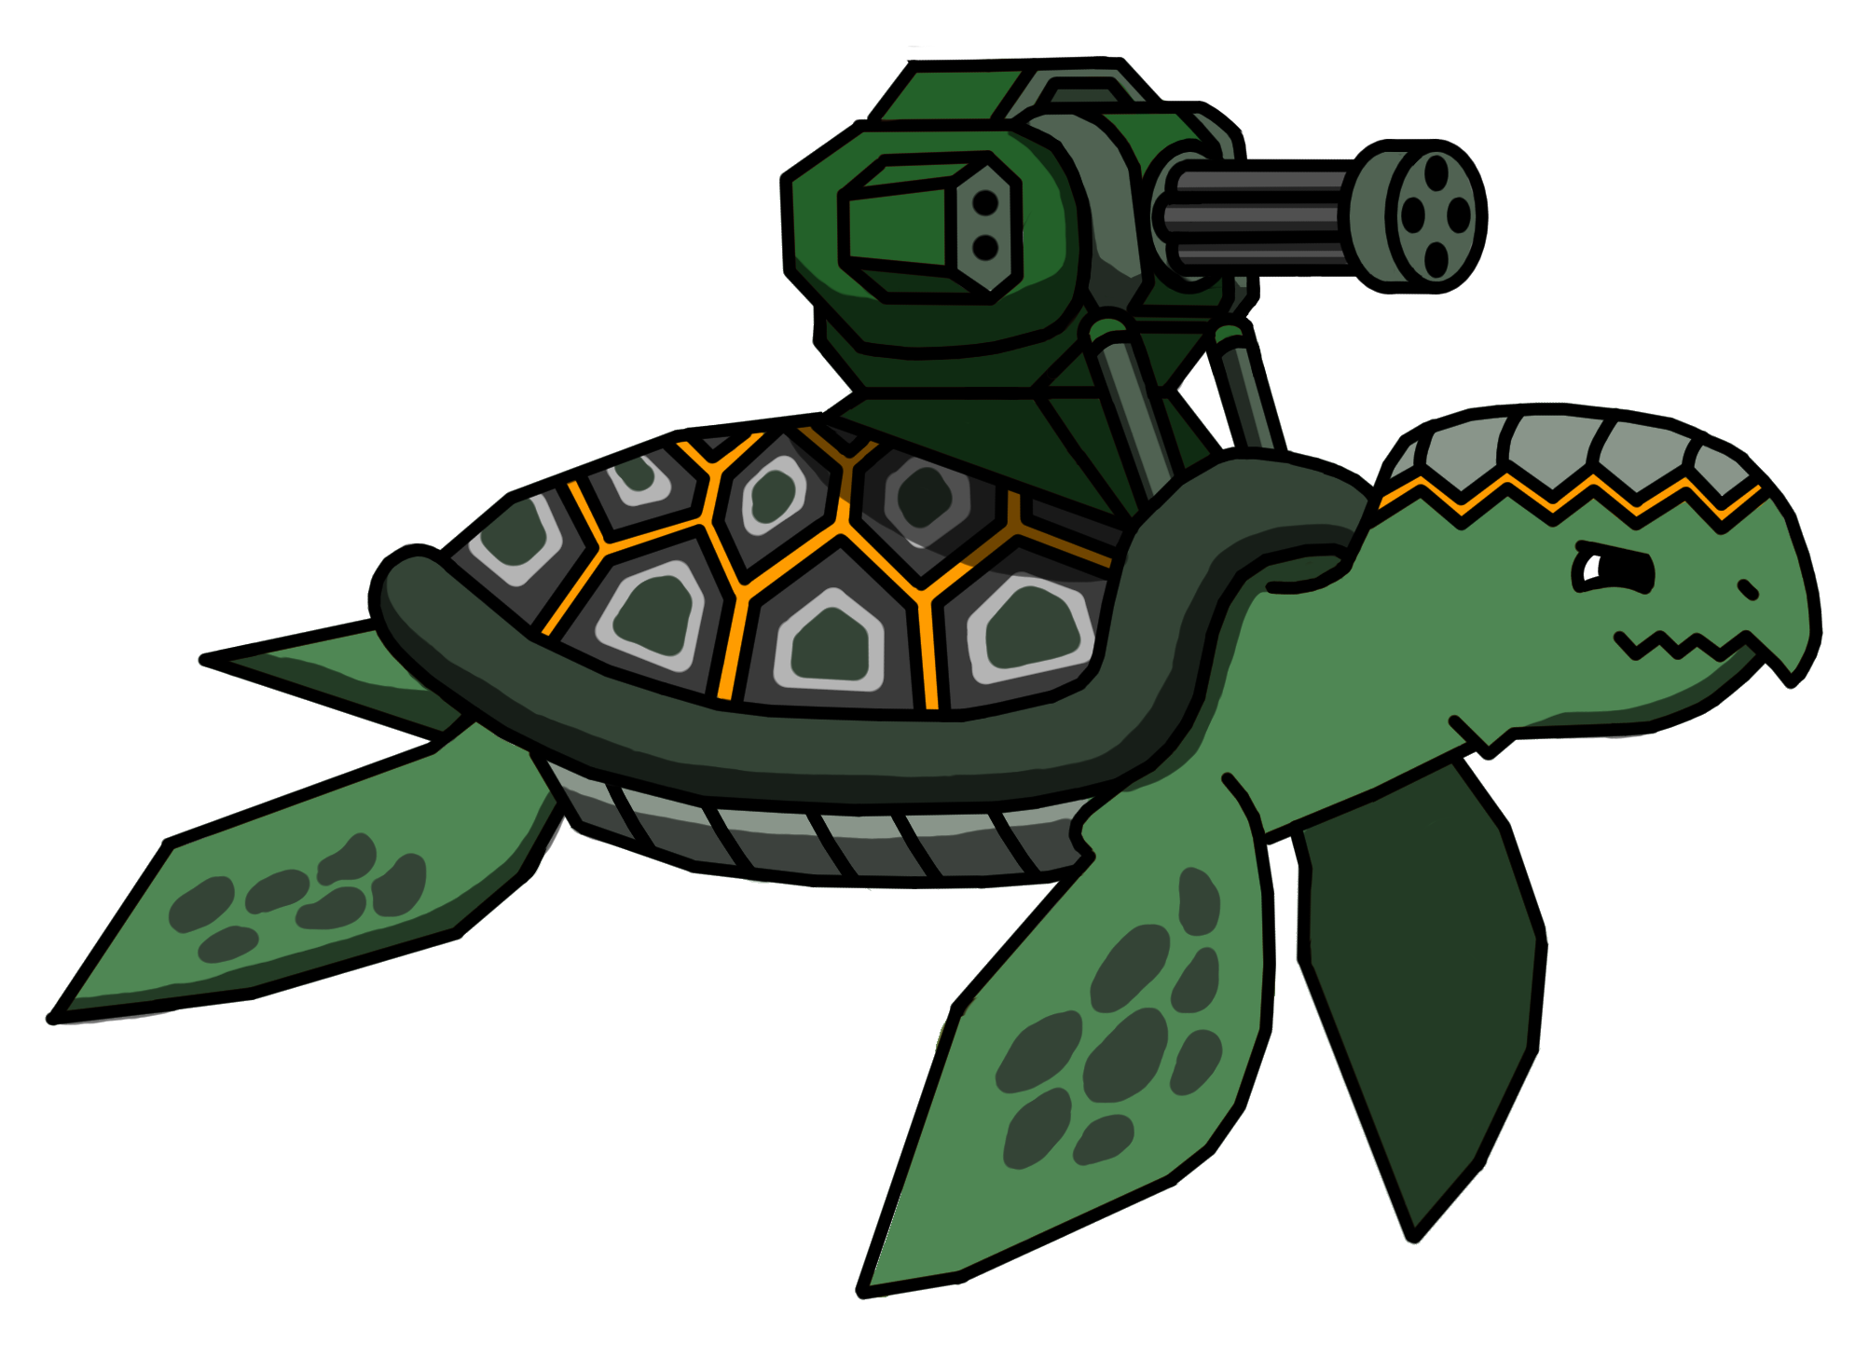

## **11.2 Metrics**

**HP:** 200

**ATTACK:** 20

**DEFENSE:** 10

**SPECIAL ATTACK:** 25

## **11.3 States**

Idle: Idle state is when monsters are in their respective conditions and are animated in a cycle  
 where they wave their 2D sprites back and forth.

Attack: When chosen, will animate the characters to rush forward and attack before reverting

to their original idle position

Defend: When chosen, the monster will stay idle.

Special Attack: When chosen, the special attack will display the monster charger forward and

enacting a more active animation.

Heal: When chosen, the monster will go into an animation where it will pluck up a large fish that  
 ultimately disappears to denote the monster consuming it before returning to idle.

**12 Player Line-up**

Crab - Lobster -

 

Angler - Snail -

 

Turtle -



# **13 Art**

**13.1 Setting**

The game takes place on a collection of islands where the brawls take place on the seas in between. It includes islands and seas, along with boids with the sprite of birds to act as indicators of encounters.

## **13.2 Level Design**

The level contains boids of sprite of birds that will swarm around their own encounters to indicate the oncoming monster battle. Five encounters will randomly generate within the collection of islands and since the battles are on the scenes, soon as they touch land they are deleted. Therefore, encounters will range a total of 1-5 per generation of islands. The encounters are clickable objects that players may click in order to start a fight.

## **13.3 Audio**

|  |  |  |
| --- | --- | --- |
| Name | Category | Description |
| Fast Fight | Background Music | Plays during fight scene |
| Blackmoor Ninjas | Background Music | Plays during Main Menu |
| Happy Adventure | Background Music | Plays during credits scene |
| The Rush | Background Music | Plays during map scene |
| AnglerSound | FX | Plays during special attack animation for the Angler monster |
| AttackSound | FX | Play during attack animation |
| BlockSound | FX | Plays during blocking animation |
| CannonSound | FX | Plays during special attack animation for the Lobster monster |
| CrabSound | FX | Plays during special attack animation for the Crab monster |
| DeathSound | FX | Plays when a monster is defeated |
| Flop | FX | Plays during special attack animation for the Snail monster |
| HealSound | FX | Plays during healing animation |
| NewTurtle | FX | Plays during special attack animation of the turtle monster |

# **14 Procedurally Generated Content**

## **14.1 Environment**

Terrain for the overworld is procedurally generated. Also boids will populated the area and circle around area where there are monsters



## **14.2 Levels**

Levels are also procedurally generated with new collections of lands, seas and sea birds as swarms of boids. The player keeps playing until they lose.

## **14.3 Artificial Intelligence**

Movements of the birds in the map scene are boid based and will swarm around their target: the encounter objects.

## **14.4 Minimum Viable Product (MPV)**

* One Player character to choose from (monster)
* Built for PC platform
* At least 3 encounters
* Enemies vary same number as player monster choices

# **15 Wish List**

**Polish**

Wish there was more time to polish the game so the assets looks sharper and higher   
 quality.

**Multiplayer**

Wish to add multiplayer functionality to allow players to team up with friends in turn-based

combat.

**Polish Boids**

Wish to polish boids and have them delete if an encounter deletes itself and maybe to  
 add a feature where birds are eaten by the encounter. In addition, maybe make

the boids stay in their circling formation better and longer while adding a

Separate boids swarm to just randomly flock around the map.

**Implement Experience system**

Wanted to implement a experience system where the player can obtain certain moves based on their experience level and set moves to a certain slot

# **16 Works Cited**

Aswin909. (2015). Water. Retrieved from <https://opengameart.org/content/water>

Levie, M. (2018). Sound FX - Retro Pack. Retrieved from   
 [https://assetstore.unity.com/packages  
 /audio/sound-fx/sound-fx-retro-pack-121743](https://assetstore.unity.com/packages/audio/sound-fx/sound-fx-retro-pack-121743)  
Pablo, M. (2014). Blackmoor Ninjas (Battle Theme). Retrieved from

<https://opengameart.org/content/blackmoor-ninjas-battle-theme>

Rubberduck. (2019). HANDPAINTED ROCK TEXTURES. Retrieved from

<https://opengameart.org/content/handpainted-rock-textures>

Tebruno99. (2012). The Rush. Retrieved from <https://opengameart.org/content/the-rush>

TinyWorlds. (2014). Happy Adventure (Loop). Retrieved from   
 <https://opengameart.org/content/happy-adventure-loop>

Ville, N. (2016). Fast fight / battle music (looped). Retrieved from   
 <https://opengameart.org/content/fast-fight-battle-music-looped>